Configuring the Hardware

Configuring RFID Reader

Cottonwood: Long Range UHF RFID reader UART

1. Connect Rx, Tx , Gnd

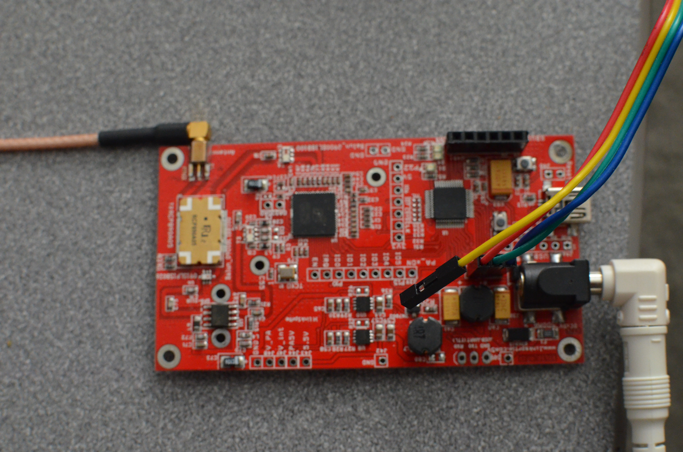

1. Connect the antenna to the RFID reader board

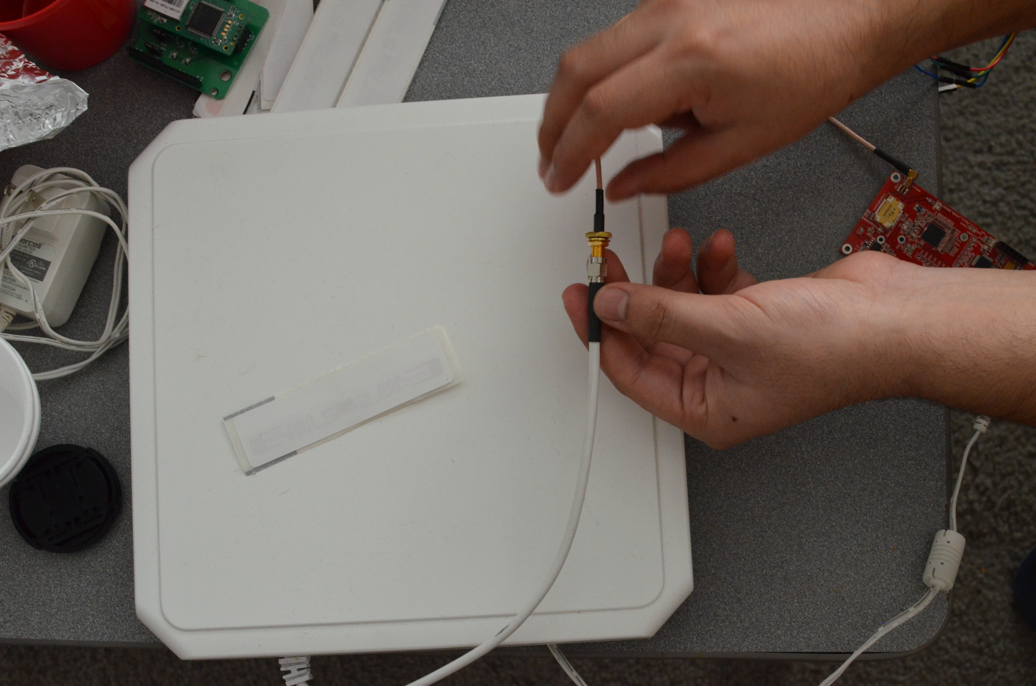

1. The RFID reader takes in 2A and 5V dc supply

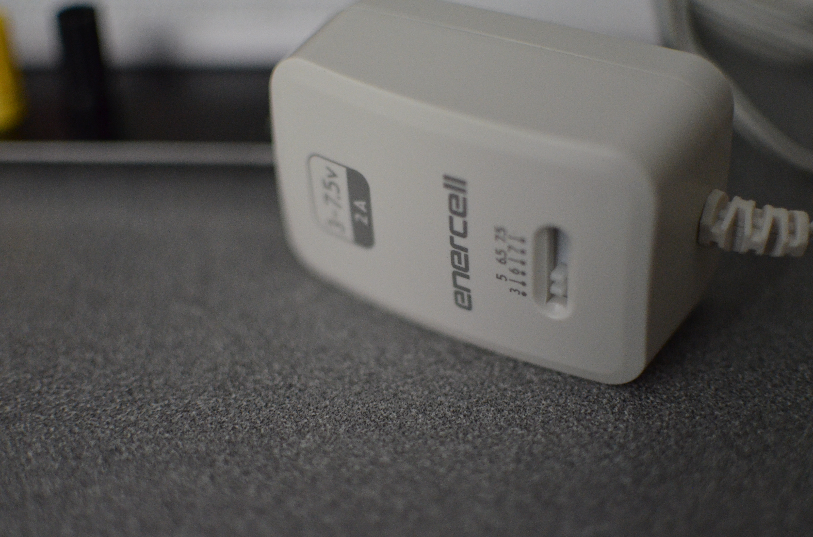

1. On Arduino connect, the RX from the RFID to the TX and TX to RX and GNd to appropriate GND in the arduino In the image below the Ethernet shield has been mounted to the arduino and the rx, tx has been configured to pin 18 and 19.

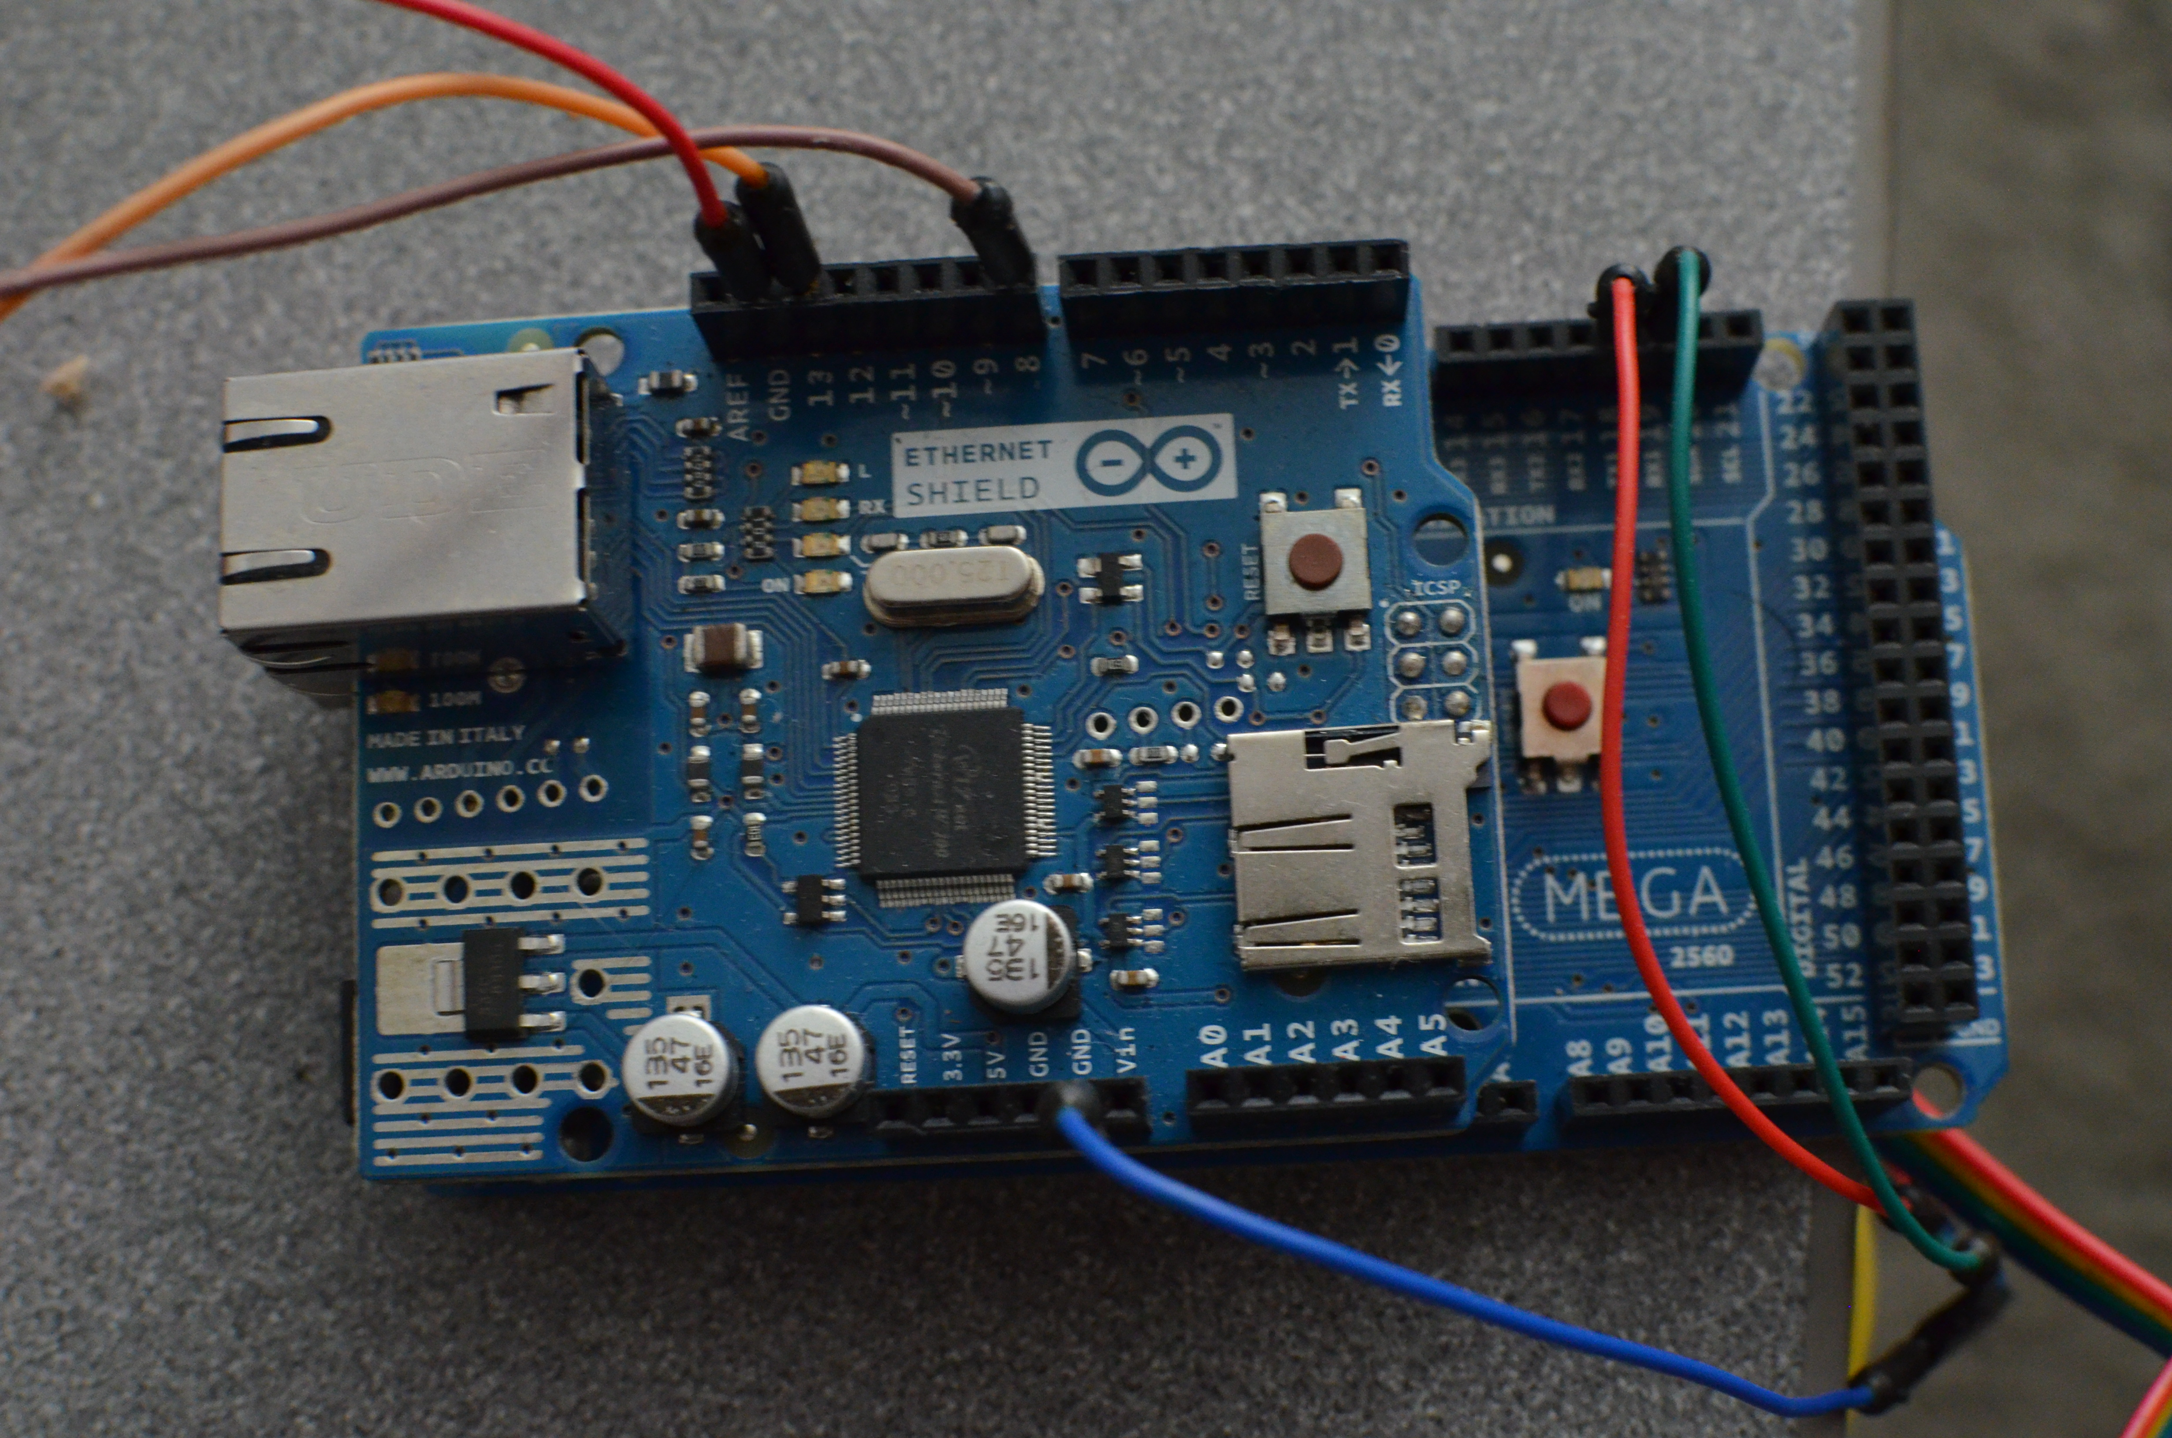

1. Pin 8 and 13 have been configured for the red and green light that shows the authentication of RFID tag
2. You can have the breadboard configured like below,

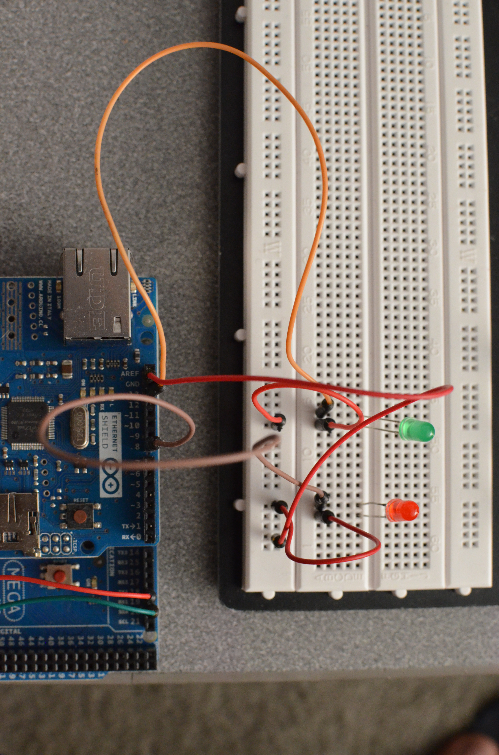

4. After uploading the code to the Arduino and setting up the http address in the arduino code. Make sure you have configured your server with the MySQL database and provided code.

5. In case of authentication or error you will see the green or red light.

